**Web Application Screen Shots**

1. **Home Screen**

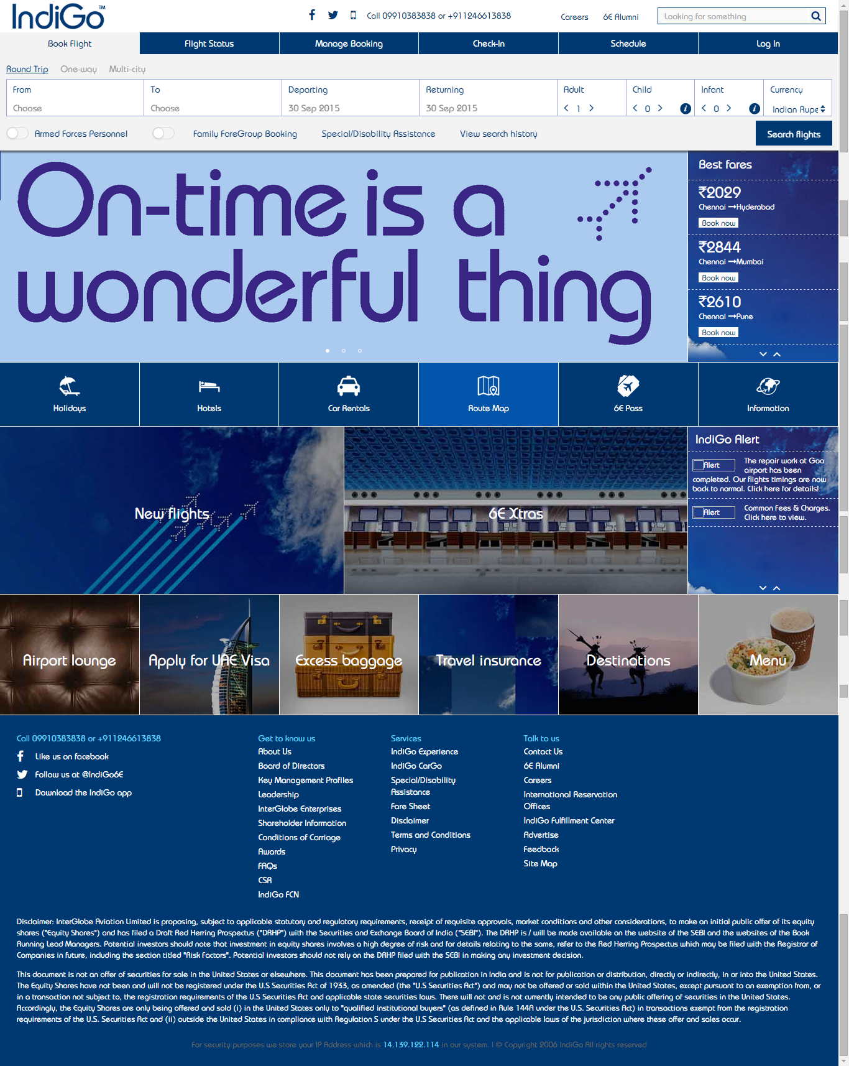

**Description:**

* To much of information and menus in one page
* User unable to find from where to search for flight

1. **Searching for flight**

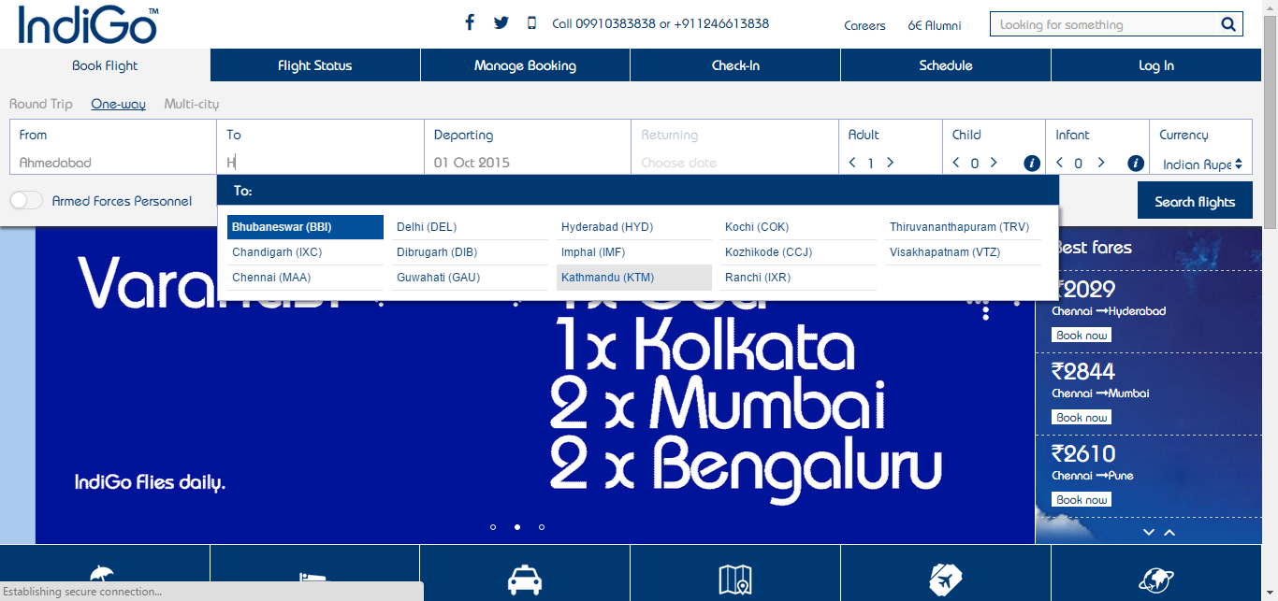

**Description:**

* Selection of source and destination with menu having frequently used cities
* Searching of city from menu by entering text

1. **Selecting flight**

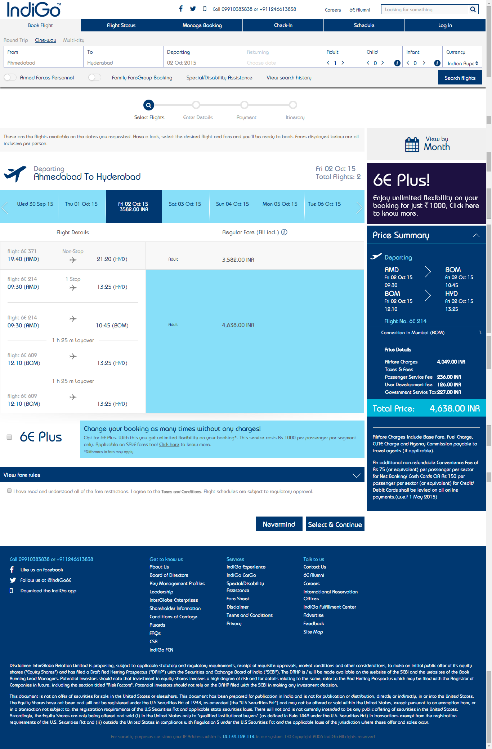

**Description:**

* Shows flight details which includes different charges, fees, and importantly halting details of flight

1. **Entering user details and selecting additional services**

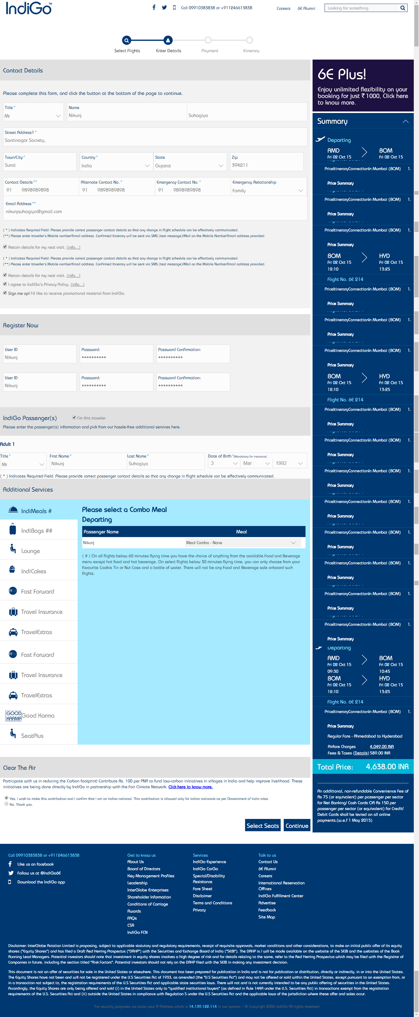

**Description:**

* Require to enter details if you are not registered and login
* Selection of one or more additional services

1. **Selecting Seat**

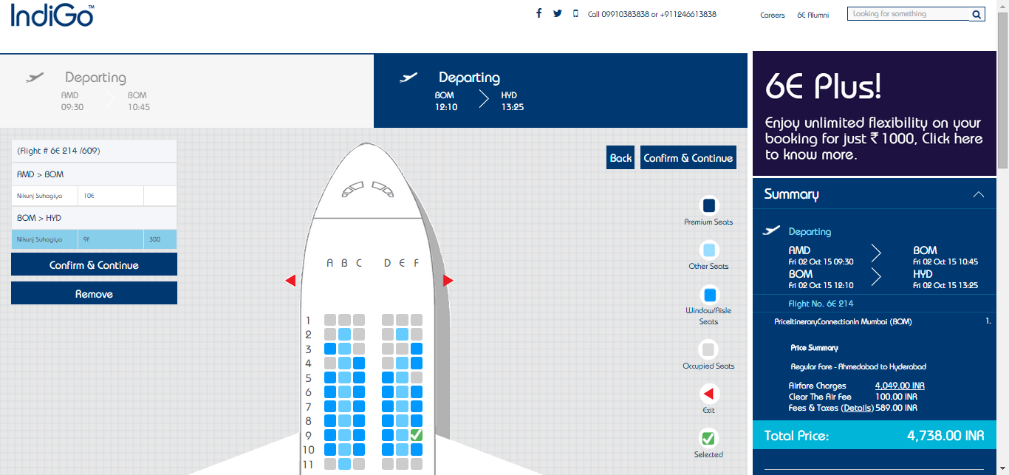

**Description:**

* Selecting seat where to seat base on given information of already selected seat, window seats etc.

1. **Payment**

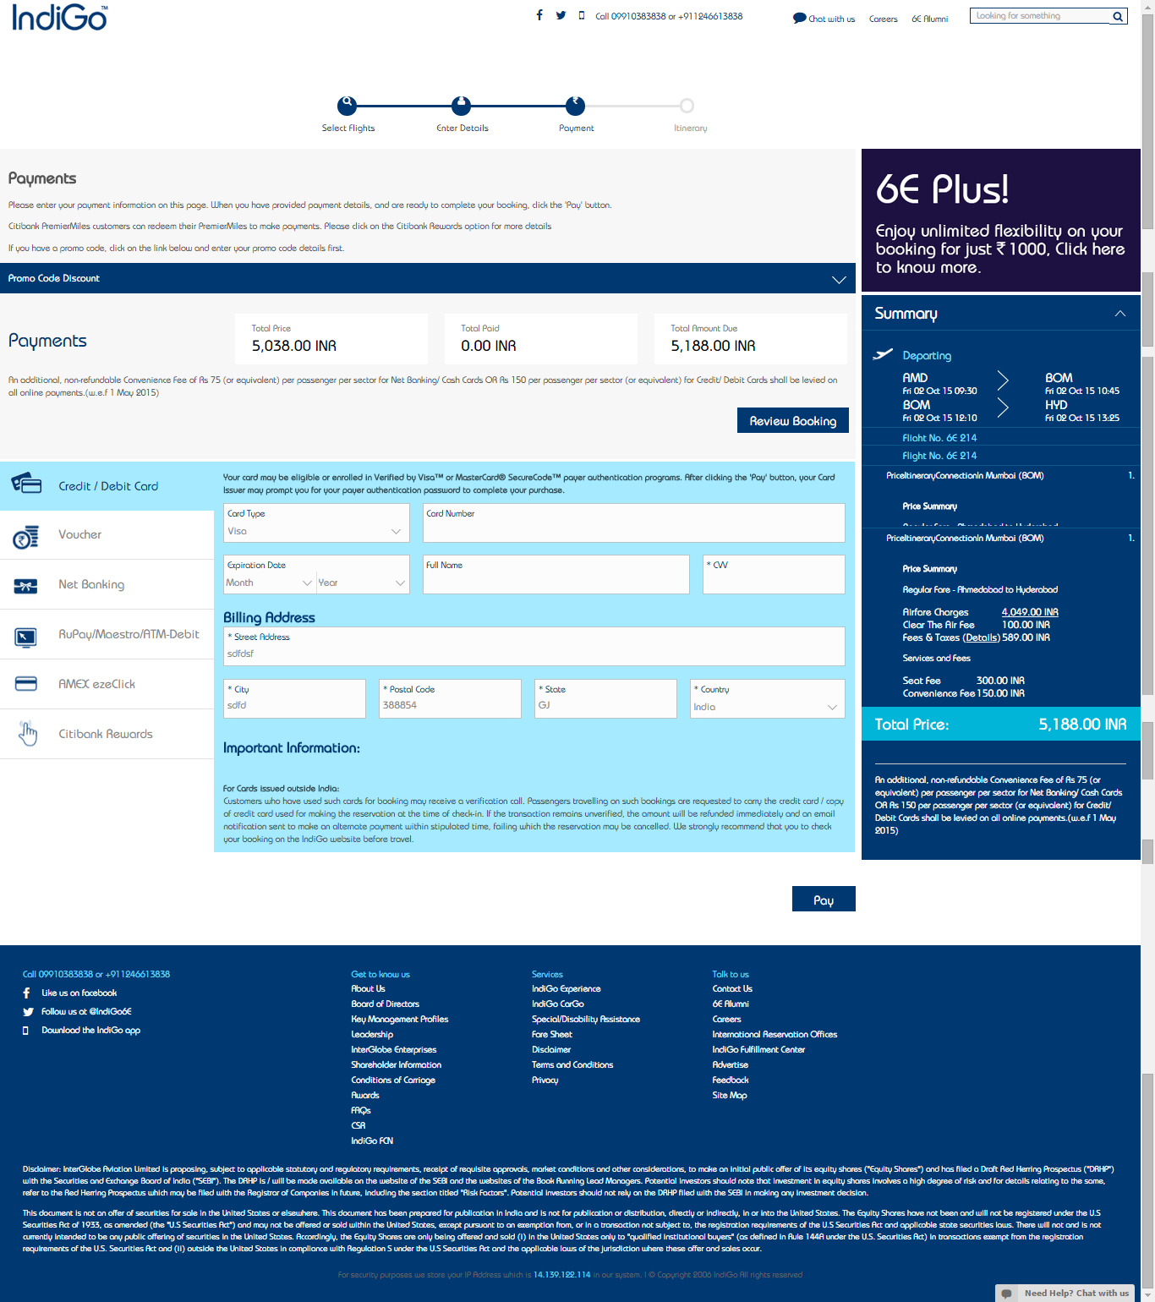

**Description:**

* Paying using various options like online banking, credit debit card etc.